**Project Design Phase-I**

|  |  |
| --- | --- |
| Date | 04 October 2022 |
| Team ID | PNT2022TMID34537 |
| Project Name | Plasma Donor Application |
| Maximum Marks | 2 Marks |

**Solution Architecture**

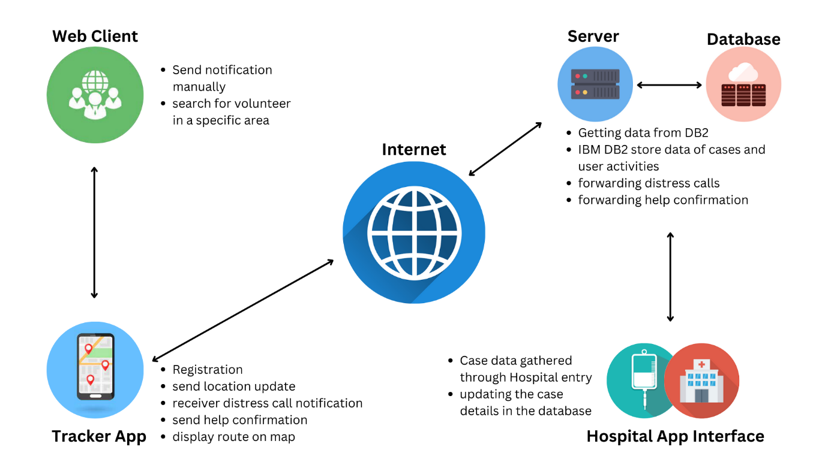

**Figure:** Architecture and data flow of the Plasma Donor application